# A1.Analysis

# Team: Pan

**Project Manager**: Chowdhary, Vanshaj

**Release Manager**: Johnson, Jessie Greg

**Quality Assurance**: Vu, Tuan Quang

**Design Technical Lead**: Yevchak, Steven C

**Scribe**: Huynh, Trung-Nghia Ngo

## Use Cases

### Use Cases for the application

|  |  |
| --- | --- |
| **Use Case Name:** | Play Game |
| **Entry Condition:** | Not currently in a game and in main menu. |
| **Exit Condition:** | Sixes Wild switches to pre-game menu. |
| **Flow of Events:** | 1. Player requests to play a new game. 2. Sixes Wild switches to pre-game menu. |

|  |  |
| --- | --- |
| **Use Case Name:** | View Scoreboard |
| **Entry Condition:** | Not currently in a game and in main menu. |
| **Exit Condition:** | Sixes Wild displays score and stars for each level. |
| **Flow of Events:** | 1. Player requests to view scoreboard for a mode. 2. Sixes Wild displays score and stars for each level in the mode. |

|  |  |
| --- | --- |
| **Use Case Name:** | View Credits |
| **Entry Condition:** | Not currently in a game and in main menu. |
| **Exit Condition:** | Sixes Wild displays credits screen. |
| **Flow of Events:** | 1. Player requests to view credits screen. 2. Sixes Wild displays credits screen. |

|  |  |
| --- | --- |
| **Use Case Name:** | Back to Main Menu |
| **Entry Condition:** | Player is in pre-game menu. |
| **Exit Condition:** | Sixes Wild displays main menu. |
| **Flow of Events:** | 1. Player requests to go back to main menu. 2. Sixes Wild displays the main menu. |

|  |  |
| --- | --- |
| **Use Case Name:** | Select Mode |
| **Entry Condition:** | Inside pre-game with mode not selected. |
| **Exit Condition:** | Game mode is selected. |
| **Flow of Events:** | 1. Player requests a game mode. 2. Sixes Wild selects game mode. |

|  |  |
| --- | --- |
| **Use case:** | Select level |
| **Entry Condition:** | - Menu access  - Not currently playing a game |
| **Exit Criteria:** | A game level is selected |
| **Flow of Event:** | 1. Player requests to select a game level. 2. Sixes Wild sets game level |

|  |  |
| --- | --- |
| **Use Case Name:** | Select Name |
| **Entry Condition:** | Player is in pre-game menu. |
| **Exit Condition:** | Sixes Wild selects the name. |
| **Flow of Events:** | 1. Player requests to select name. 2. Sixes Wild selects the name. |

|  |  |
| --- | --- |
| **Use case:** | Start game |
| **Entry Condition:** | - Menu access  - Not currently playing a game  - A game mode is selected  - A game level is selected |
| **Exit Criteria:** | A new game starts |
| **Flow of Event:** | 1. Player requests to start game 2. Sixes Wild starts a game |

|  |  |
| --- | --- |
| **Use case:** | See current game mode and level |
| **Entry Condition:** | Currently playing a game |
| **Exit Criteria:** | Game mode and level is shown |
| **Flow of Event:** | 1. Player requests to see current game mode and level. 2. Sixes Wild shows current game mode and level |

|  |  |
| --- | --- |
| **Use case:** | See current game statistics |
| **Entry Condition:** | Currently playing a game |
| **Exit Criteria:** | Current game statistics are shown |
| **Flow of Event:** | 1. Player requests to see current game statistics 2. Sixes Wild shows current game statistics |

|  |  |
| --- | --- |
| **Use case:** | Quit Game |
| **Entry Condition:** | Player is currently playing a game. |
| **Exit Criteria:** | Sixes Wild switches to the main menu screen. |
| **Flow of Event:** | 1. Player requests to quit the game. 2. Sixes wild quits the game, and switches to the main menu screen. |

|  |  |
| --- | --- |
| **Use Case Name:** | Win Game |
| **Entry Condition:** | Player is currently playing a game. |
| **Exit Condition:** | Sixes Wild switches to the post-game menu and unlocks the next level. |
| **Flow of Events:** | 1. Player satisfies the winning conditions of the game. 2. Sixes Wild switches to the post-game menu and unlocks the next level. |

|  |  |
| --- | --- |
| **Use Case Name:** | Lose Game |
| **Entry Condition:** | Player is currently playing a game. |
| **Exit Condition:** | Sixes Wild switches to the post-game menu. |
| **Flow of Events:** | 1. Player runs out of time/moves and has not reached winning condition. 2. Sixes wild switches to the post-game menu. |

|  |  |
| --- | --- |
| **Use Case Name:** | Remove tiles |
| **Entry Condition:** | Player is currently playing a game and the selected tiles add up to 6. |
| **Exit Condition:** | Sixes Wild removes the selected tiles, updates score, and updates the board. |
| **Flow of Events:** | 1. Player requests to remove tiles. 2. Sixes Wild removes the tiles, updates score, and updates the board. |

|  |  |
| --- | --- |
| **Use Case Name:** | Select group of tiles |
| **Entry Condition:** | Player is currently playing a game |
| **Exit Condition:** | Sixes wild selects the group of tiles. |
| **Flow of Events:** | 1. Player requests to select a group of tiles. 2. Sixes Wild selects the tiles. |

|  |  |
| --- | --- |
| **Use Case Name:** | Update Score |
| **Entry Condition:** | A valid move has been made by the player. |
| **Exit Condition:** | Sixes Wild updates the score |
| **Flow of Events:** | 1. Player makes a move. 2. Sixes Wild updates the score based on the move. |

|  |  |
| --- | --- |
| **Use Case** | Use power-up swap |
| **Entry Condition** | There are at least two tiles on the board |
| **Exit Criteria** | The contents of two selected tiles are swapped |
| **Flow of Events** | 1. Player requests to swap two tiles. 2. Board is updated to reflect tiles swap. |

|  |  |
| --- | --- |
| **Use Case** | Use power-up remove |
| **Entry Condition** | There is at least one tile on the board |
| **Exit Criteria** | The content of the selected tile *a* is removed; the tiles above *a* in the same column shift downward one tile; one new tile is created at top |
| **Flow of Events** | 1. Player requests to remove one tile. 2. Board is updated to reflect removed tile. |

|  |  |
| --- | --- |
| **Use Case** | Use power-up reset |
| **Entry Condition** | Tiles remain on the board |
| **Exit Criteria** | The contents of all the tiles on the board are randomly swapped |
| **Flow of Events** | 1. Player requests to reset the board. 2. Board is updated to reflect board reset. |

|  |  |
| --- | --- |
| **Use Case Name:** | Restart level |
| **Entry Condition:** | Player has finished the level and is in the post-game menu. |
| **Exit Condition:** | Sixes Wild starts the same level again. |
| **Flow of Events:** | 1. Player requests to restart level. 2. Sixes Wild restarts level. |

|  |  |
| --- | --- |
| **Use Case Name:** | Back to Main Menu |
| **Entry Condition:** | Player has finished the level and is in post-game menu. |
| **Exit Condition:** | Sixes Wild switches to main menu screen. |
| **Flow of Events:** | 1. Player requests to main menu. 2. Sixes Wild switches to main menu. |

|  |  |
| --- | --- |
| **Use Case Name:** | Go To Next Level |
| **Entry Condition:** | Player finished a level and requests to go to the next level |
| **Exit Condition:** | Sixes’ Wild starts the next level. |
| **Flow of Events:** | 1. Player requests to go to the next level. 2. Sixes’ Wild starts the next level in the mode. |

|  |  |
| --- | --- |
| **Use Case Name:** | Go To Main Menu |
| **Entry Condition:** | Player finished a level and requests to go to main menu. |
| **Exit Condition:** | Sixes’ Wild switches to the main menu screen. |
| **Flow of Events:** | 1. Player requests to go to the main menu. 2. Sixes’ Wild opens the main menu screen. |

|  |  |
| --- | --- |
| **Use Case Name:** | Update high score |
| **Entry Condition:** | Player finished a level and has gotten a higher score than previous high score. |
| **Exit Condition:** | Sixes Wild updates the high score for the level. |
| **Flow of Events:** | 1. Player finishes a level. 2. Sixes wild updates the high score. |

### Use Cases for Level Builder

|  |  |
| --- | --- |
| **Use Case Name:** | Create a level |
| **Entry Condition:** | None. |
| **Exit Condition:** | Level Builder creates a level. |
| **Flow of Events:** | 1. Creator requests to create a level. 2. Level Builder creates the level. |

|  |  |
| --- | --- |
| **Use Case Name:** | Set level and mode |
| **Entry Condition:** | Level Builder has been started. |
| **Exit Condition:** | The Mode and the Level have been selected. |
| **Flow of Events:** | 1. Creator requests to create a level with a specific mode and level number. 2. Level Builder selects the level and mode. |

|  |  |
| --- | --- |
| **Use Case Name:** | Set winning conditions |
| **Entry Condition:** | Creator has selected the mode and the level and requests to set the winning conditions |
| **Exit Condition:** | Level Builder sets the winning conditions. |
| **Flow of Events:** | 1. Creator requests to set the level with the moves/time remaining, and required score. 2. Level Builder sets the level with the moves/time remaining, and required score. |

|  |  |
| --- | --- |
| **Use Case Name:** | Set Power-ups |
| **Entry Condition:** | None. |
| **Exit Condition:** | Level Builder sets the number of power-ups for the level. |
| **Flow of Events:** | 1. Creator requests for a number of power-ups to be allowed in the level. 2. Level Builder sets the number of power-ups for the level. |

|  |  |
| --- | --- |
| **Use Case Name:** | Set Starting Board |
| **Entry Condition:** | Creator has selected the mode. |
| **Exit Condition:** | Level Builder sets the starting board. |
| **Flow of Events:** | 1. Creator requests to set the starting board. 2. Level Builder sets the starting board. |

|  |  |
| --- | --- |
| **Use Case Name:** | Set star requirements |
| **Entry Condition:** | None. |
| **Exit Condition:** | Level Builder sets the score required for achieving getting stars. |
| **Flow of Events:** | 1. Creator request to set star requirements. 2. Level Builder sets the star requirements. |

|  |  |
| --- | --- |
| **Use Case Name:** | Set probability of each value |
| **Entry Condition:** | None |
| **Exit Condition:** | Level Builder sets the probability for values 1 through 6. |
| **Flow of Events:** | 1. Creator requests to set the probability for each value appearing. 2. Level Builder sets the probability for each value appearing. |

|  |  |
| --- | --- |
| **Use Case Name:** | Set probability of multiplier |
| **Entry Condition:** | None. |
| **Exit Condition:** | Level Builder sets the probability of getting x1, x2, and x3 multipliers. |
| **Flow of Events:** | 1. Creator requests to set the probability of the multipliers 2. Level Builder sets the probability of the multipliers. |

|  |  |
| --- | --- |
| **Use Case Name:** | Randomize Level |
| **Entry Condition:** | None. |
| **Exit Condition:** | Level Builder randomly sets the mode, winning conditions, starting board, score requirements for stars, and the probability for tiles and multipliers. |
| **Flow of Events:** | 1. Creator requests to randomize level. 2. Level Builder randomly sets the mode, winning conditions, starting board, score requirements for stars, and the probability for tiles and multipliers. |

|  |  |
| --- | --- |
| **Use Case Name:** | Load level |
| **Entry Condition:** | None. |
| **Exit Condition:** | Level Builder loads the level. |
| **Flow of Events:** | 1. Creator requests to load a level. 2. Level Builder loads the level. |

|  |  |
| --- | --- |
| **Use Case Name:** | Save level |
| **Entry Condition:** | Creator has created a level. |
| **Exit Condition:** | Level Builder saves the level. |
| **Flow of Events:** | 1. Creator requests to save the level. 2. Level Builder saves the level. |

## Mockup GUI

### Splash Screen



### Main Menu



### Scoreboard Menu



### Credits Menu



### Pre-game Menu



### In-game Menu



### Post-game Menu



### Level Builder



## Use Case Diagrams

### In-game Entity Diagram

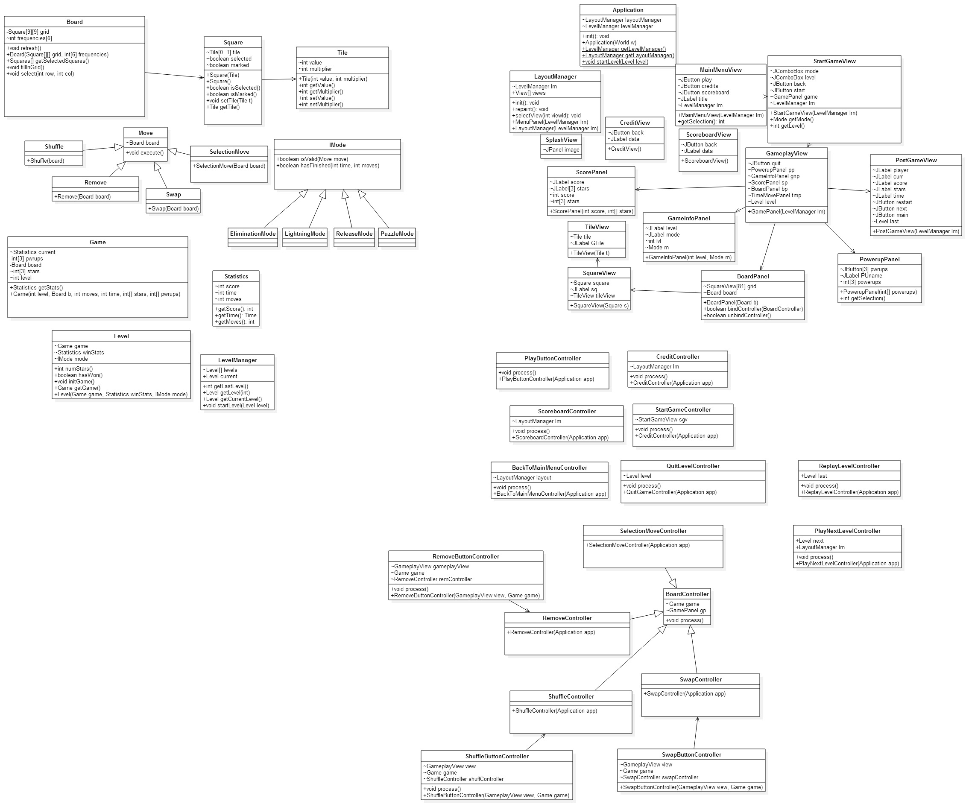

### In-game Boundary Diagram



### In-game Controller Diagram



### Level Builder Entity Diagram

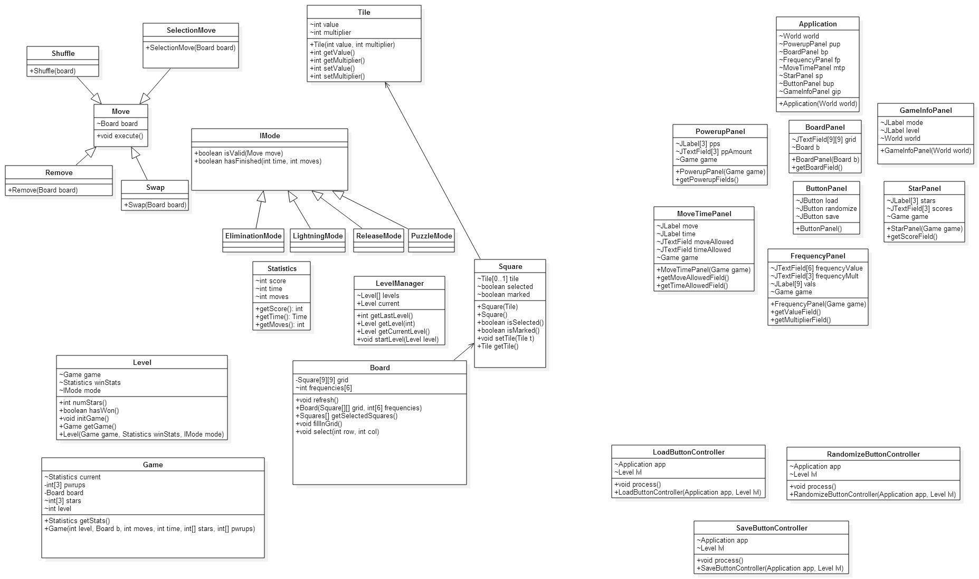

### Level Builder Boundary Diagram



### Level Builder Controller Diagram

